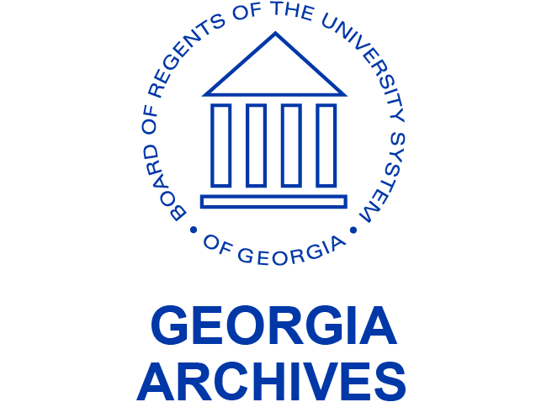
Contact Penny Cliff  Telephone 678.364.3807  Email Penelope.Cliff@usg.edu  Website http://www.georgiaarchives.org/ | FOR IMMEDIATE RELEASE  November 17, 2022

November Virtual Presentation
“The Georgia Archives: A Brief Overview and Update”

Join us for the Georgia Archives November webinar, “The Georgia Archives: A Brief Overview and Update” by State Archivist and Assistant Vice Chancellor of the University System of Georgia, Christopher Davidson on Wednesday, November 30, from noon to 1:00 p.m.
State Archivist Christopher Davidson will give a brief overview of the history of the Georgia Archives and then focus on recent activities and plans for next year.

Christopher Davidson has worked in the archives field for over 28 years, including with the Alabama Department of Archives and History and the Alabama Department of Transportation. He has been State Archivist of Georgia for over 9 years. Davidson received his BA in History and MLA with a focus on Southern Literature and History from Auburn University Montgomery, and his JD from Thomas Goode Jones School of Law.

Follow this link to register for the webinar: https://tinyurl.com/ms7dj68j

Download the free Microsoft Teams app prior to the event and register through the link above. The link to this presentation will also be available on the Georgia Archives webpage: www.georgiaarchives.org
The Georgia Archives is a unit of Board of Regents of the University System of Georgia. The Georgia Archives identifies, collects, manages, preserves, provides access to, and publicizes records and information of Georgia and its people, and assists state and local government agencies with their records management.

